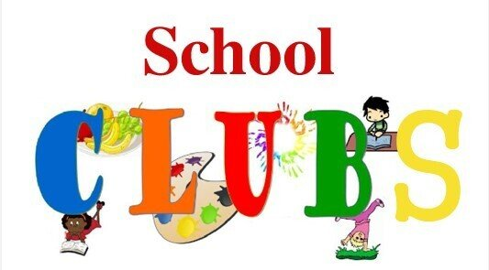

|  |  |  |  |  |  |
| --- | --- | --- | --- | --- | --- |
|  | **MONDAY** | **TUESDAY** | **WEDNESDAY** | **THURSDAY** | **FRIDAY** |
| **BREAKFAST CLUB** |  |  |  |  | **8.00– 8.45AM**  **REFLECTION GANG**  **8.00– 8.45AM**  **ALTERNATE WEEKS**  **MRS BIRD** |
| **AFTER SCHOOL** | **ACCRINGTON STANLEY FOOTBALL CLUB** | **KEYSTAGE 2**  **CHOIR**    **MRS MORGAN** | Mad Science - Wikipedia  **MAD SCIENCE CLUB** | **MRS PARTINGTON AND**  **MRS BIRD** | **CHAPLAINS**  **MRS BIRD** |
| **LEGO ROBOTICS**    **MR MCNAB** | **SPORTS CLUB**    **MISS GREENWOOD** |